Notes
Measures of Effect and Precision: an Introduction
Measures of Effect
Absolute measures of effect
  - Absolute risk reduction (ARR): the difference in absolut risk between groups
  - Number needed to treat (NTT): the number of patients that need to be treated to prevent one outcome (can be calculated as 1/ARR or 100/ARR%)
Relative measures
  - Relative risk (RR): the relative change of risk to experience the outcome between the two groups (usually intervention and control)
  - Relative risk reduction: the reduction in risk from administering the intervention (compared to control), can be calculated as 1-RR
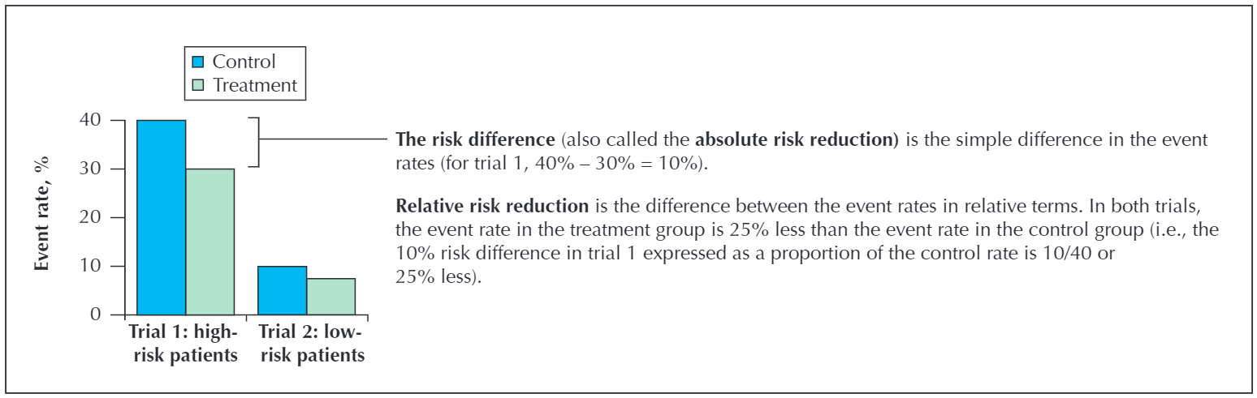
  - Odds ratio (OR): the relative change of odds to experience the outcome between the two groups (usually intervention and control)
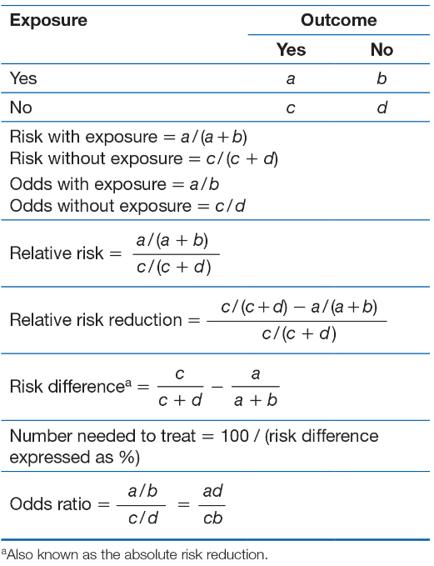

Measures of Precision

P-value
- Probability of observing a difference by chance alone

Confidence interval
- When using a 95% confidence interval, we can be 95% confident that the true effect lies within the given interval (in the absence of bias).
